**ENTITY RELATIONSHIP DIAGRAM**

nhy65

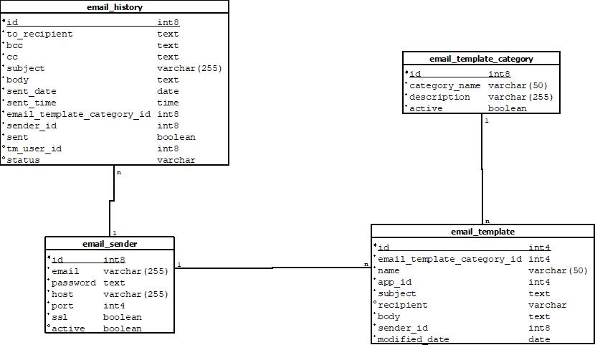

**KAMUS DATA**

Email_history

|  |  |  |  |
| --- | --- | --- | --- |
| Nama kolom | *Default* | Tipe data | Keterangan |
| id | nextval('email_history_  id_seq'::regclass) | int8 | kode unik email_history |
| to_recipient |  | text | penerima email |
| bcc |  | text | bcc |
| cc |  | text | cc |
| subject |  | varchar | subjek email |
| body |  | text | isi email |
| sent_date |  | date | tanggal pengiriman email |
| sent_time |  | time | jam email terkirim |
| email_template_category_id | 0 | int8 | id kategori email template |
| sender_id |  | int8 | id pengirim email |
| sent | false | boolean | email terkirim atau gagal |
| tm_user_id |  | int8 | username admin pengirim email |
| status |  | varchar | status email |

Email_template

|  |  |  |  |
| --- | --- | --- | --- |
| Nama kolom | *Default* | Tipe data | Keterangan |
| id | nextval('email_template_  id_seq'::regclass) | int4 | kode unik email_template |
| email_template_category_id |  | int4 | id kategori email template |
| name |  | varchar | nama email template |
| app_id |  | int4 | id app |
| subject |  | text | subjek email |
| body |  | text | isi email |
| sender_id |  | int8 | id pengirim email |
| modified_date |  | date | tanggal modifikasi |
| recipient |  | text | penerima |

Email_sender

|  |  |  |  |
| --- | --- | --- | --- |
| Nama kolom | *Default* | Tipe data | Keterangan |
| Id | nextval('email_sender_  id_seq'::regclass) | Int8 | Kode unik email_sender |
| Email |  | Varchar | Email pengirim |
| Password |  | Text | Password email |
| Host |  | Varchar | Host |
| Port |  | Int4 | Port |
| ssl |  | Boolean | Ssl / tsl |
| active |  | boolean | Aktif / tidak aktif |

Email_template_category

|  |  |  |  |
| --- | --- | --- | --- |
| Nama kolom | *Default* | Tipe data | Keterangan |
| Id | nextval('email_template_  category_id_seq'::regclass) | Int8 | Kode unik email_template_category |
| Category_name |  | Varchar | Nama kategori |
| Active | true | Boolean | Aktif / tidak aktif |
| description |  | varchar | deskripsi |